Cornwall Dashboard setup

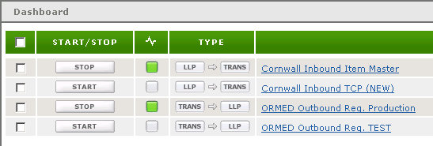

Cornwall Inbound Item Master LLP settings

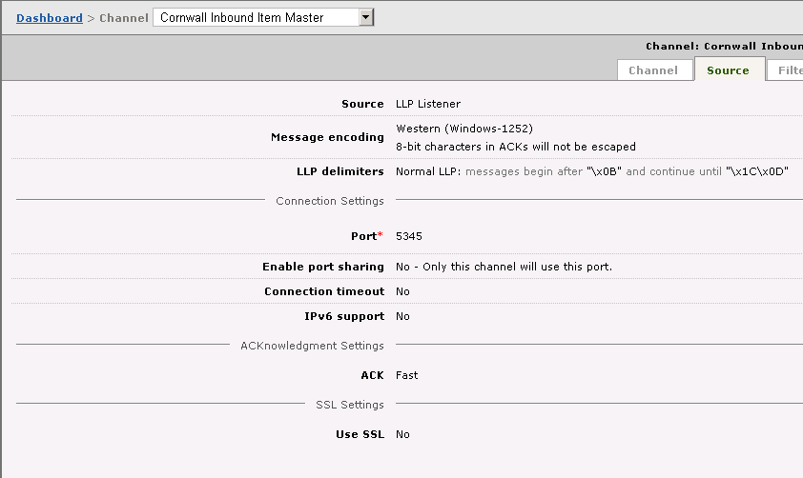

Cornwall Inbound TCP (NEW) LLP settings

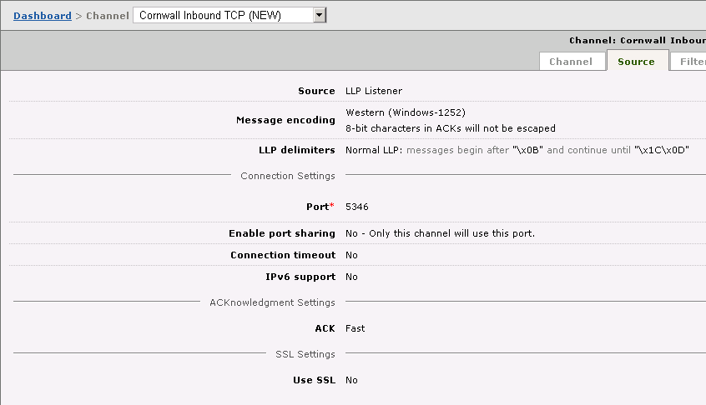

Cornwall ORMED Outbound Req. Production LLP settings & Cornwall ORMED Outbound Req. Production LLP settings

